AL 811H and AL 811 Fan Kit
Initial Design
Temperature rise in any closed space is a function of air mass exchange rate and the total power dissipated as heat. I designed the AL811 and AL811H amplifiers as the cheapest possible amplifier for medium power amateur SSB and CW use only. The design was long before FT8, and never intended for AM use. Correct minimum airflow is about 18-20 cfm on normal SSB and CW with three tubes (25% less power), and 25-28 cfm on higher duty cycle modes for four 811 tubes. This is for a 40ºF increase at maximum average tube dissipation. The tubes safely dissipate about 60-watts per tube average anode heat, while filament and other power losses amount to about 120 watts in the AL811H and 95 watts in the AL811. Use of 572 tubes does not change the power ratings, it just makes tuning much more forgiving and allows the three tube 811 to run the same power as the 811H.
No matter what tubes are used in the 811 series when dissipated power is the same total thermal rise will be the same for the same airflow rate.
Some Ameritron 811 amplifiers have far too little airflow for normal SSB operation. This Cooltron fan is especially bad. It flows roughly 1/3 of proper airflow. This fan has excessive temperature rise even on casual SSB use with the three tube models. If your amplifier has this factory installed fan, it must be changed:
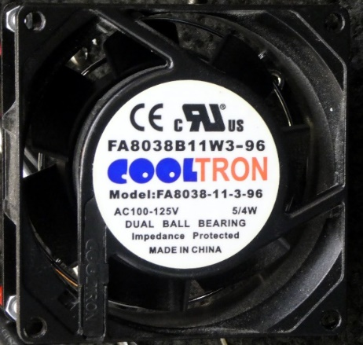
If you live in a country with 50Hz mains, this fan will only flow 5 cfm. Flow is too low even with the amp on standby.
Airflow is difficult to measure, this is why we did this work for you. While not an absolute test, a good breeze should be felt some distance from the exhaust holes. A Zippo lighter will have problems staying lit over a foot from the amplifier side. In general, the more airflow, the longer components will last.
KF811 and KF811H
We now offer a convenient drop-in fan for both the AL-811H internal fan, and external-fan AL-811 three tube amplifiers. Note the external 811 fan and internal 811H fans are slightly different.
Our fan selection is a standard 45 CFM, 3.2 x 3.2 x 1.0 inch, 12Vdc 0.2 ampere fan. It is sleeve bearings, which are actually quieter than ball bearings. If you decide to buy your own fan, we recommend a Keyfanclub 45cfm fan. This fan draws 0.2 amperes and flows over 25cfm in the actual amplifier. (If you use your own fan, be aware many fans do not meet advertised rated free air. About half of fans tested fail to meet advertised specs in open air. All fans will flow considerably less through an amplifier.)

This particular fan flows near 18 cfm on low voltage (~10Vdc) and near 25 cfm at 15Vdc, the typical AL811 full bus voltage. This flow rate is with the amplifier cover on. The fan rating is 45cfm free air, but this does not mean all 45cfm fans will work the same in the amplifier.
Be aware a few 811 amps, due to transformer winding errors, might range up to 17Vdc. If you are going to run the fan at high speed (full voltage) most of the time, check your amplifier’s yellow wire voltage. Voltage may have to be reduced with a Zener.
The advantages of a 12V fan are:
1.) Much wider selection
2.) Same performance on 50 or 60 Hz mains
3.) Lower cost
4.) Reduced fan depth
5.) Easier installation and wiring
6.) Easier fan speed control

KF811 and KF811H Installation

These kits are 12-volt RF noise suppressed two-speed systems with fuse. Note the 811H internal fan and 811 external fan systems are different. Make sure you have the correct system for internal or external fan use:
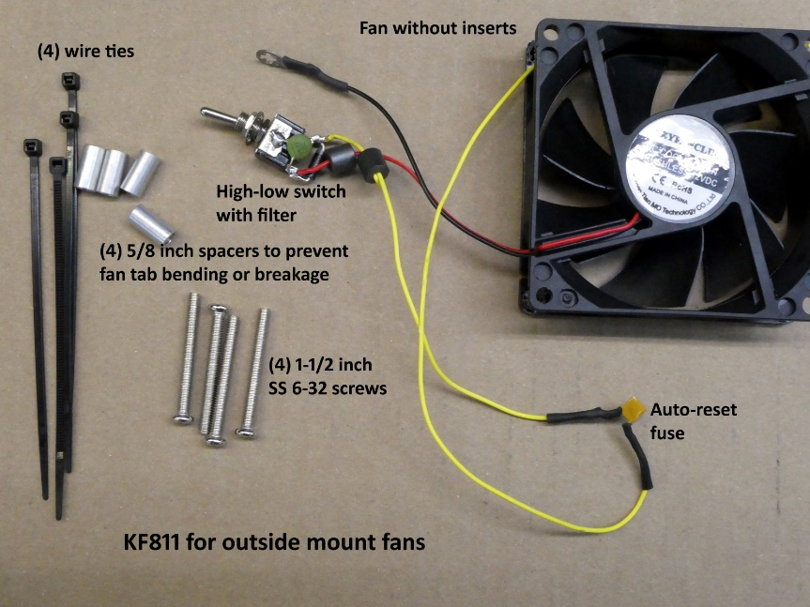

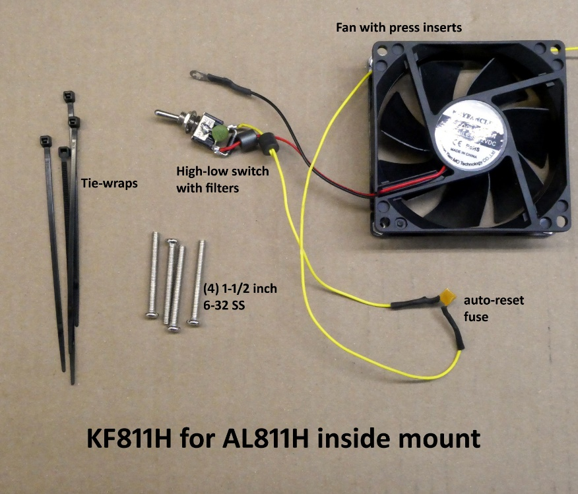

Tools:
screwdrivers long nose pliers soldering iron at least 700F small tip
60/40 rosin solder small wire cutters, longer reach is easier
¼ inch combination open-end and box-end wrench (the longer the better)
- Observe the HV meter position. Make sure it is working, and then turn the amplifier off and watch the HV decrease. When HV reaches zero the amplifier HV is discharged.

- Unplug the amplifier from the outlet and remove the cover. Observe this area. Remove the small fan wires by unsoldering or by just cutting. If any tie is holding the fan wires, carefully cut it.

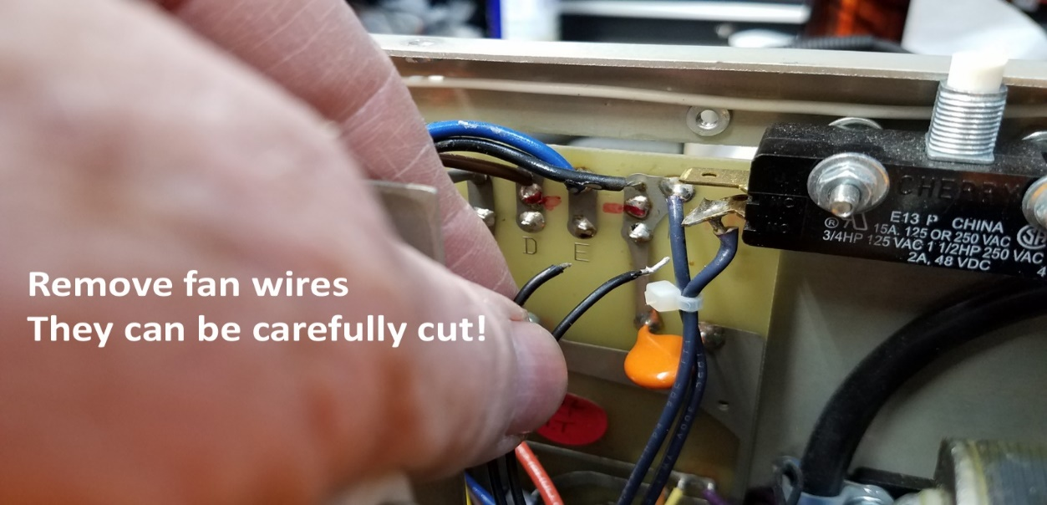

- Unbolt the fan. (Save the hardware.)
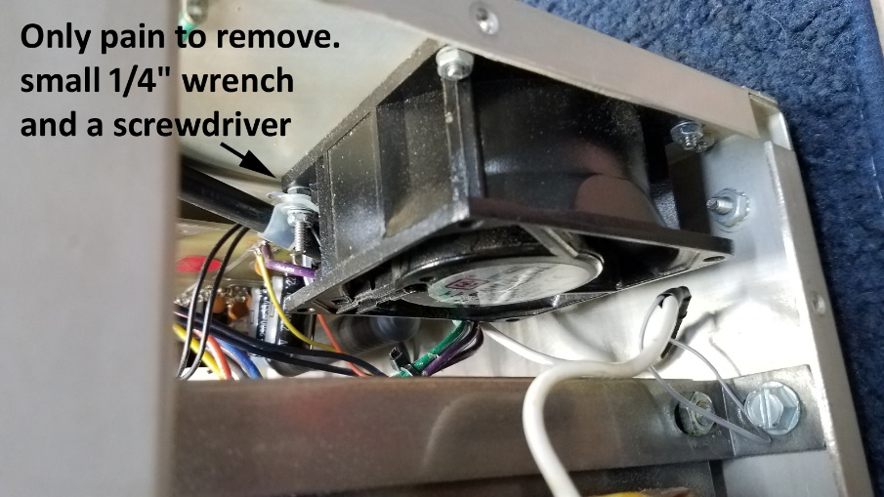
- Remove the fan, you will not reuse screws.
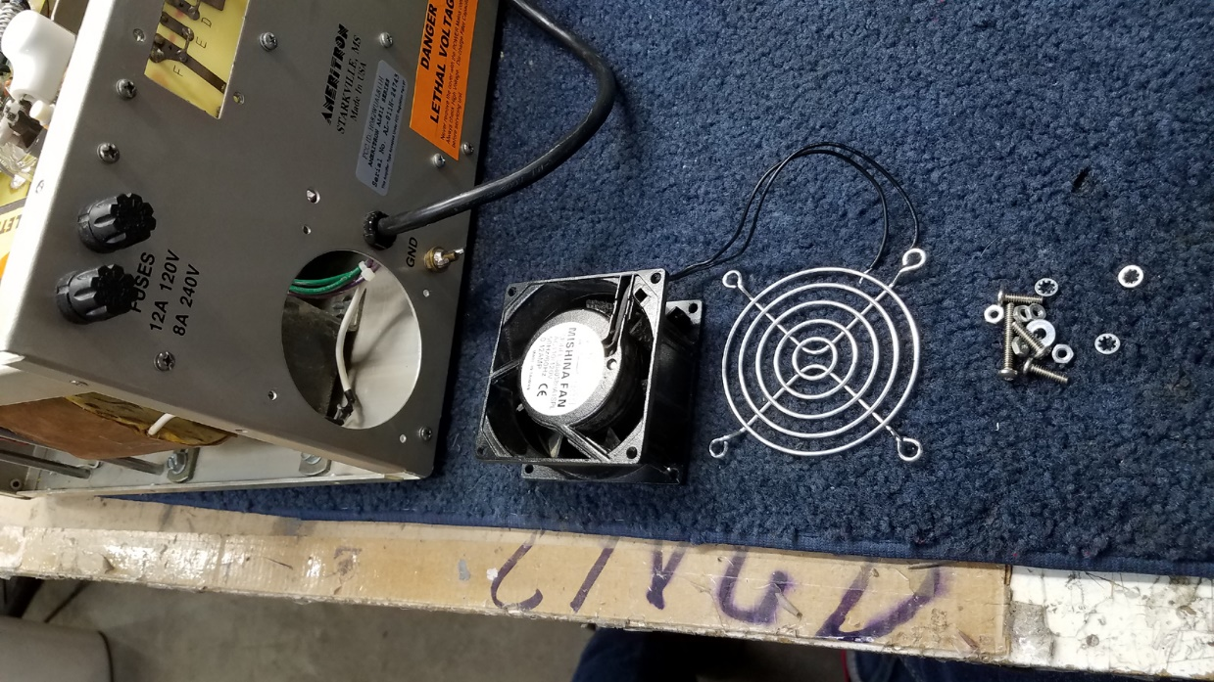

- Rear mount fans use this hardware stack. The spacers allow you to tighten the screws without breaking or bending the fan mounting tabs.

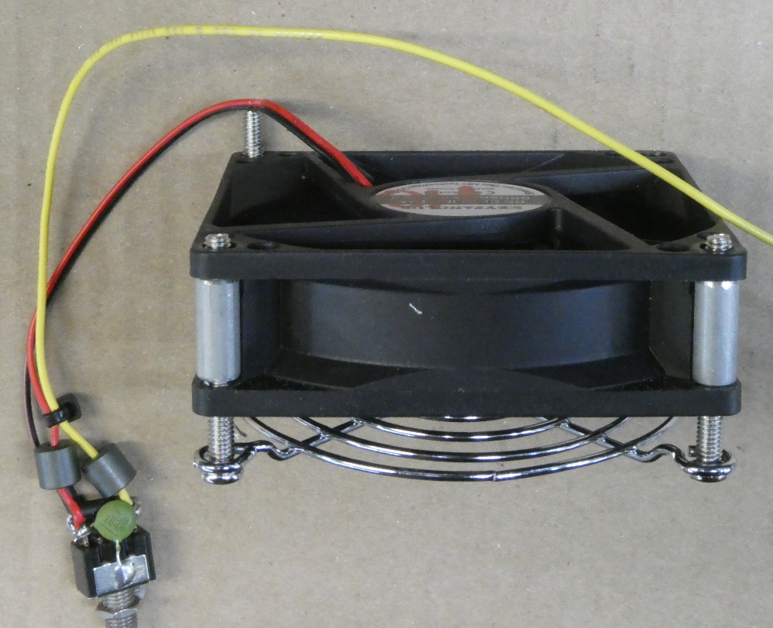

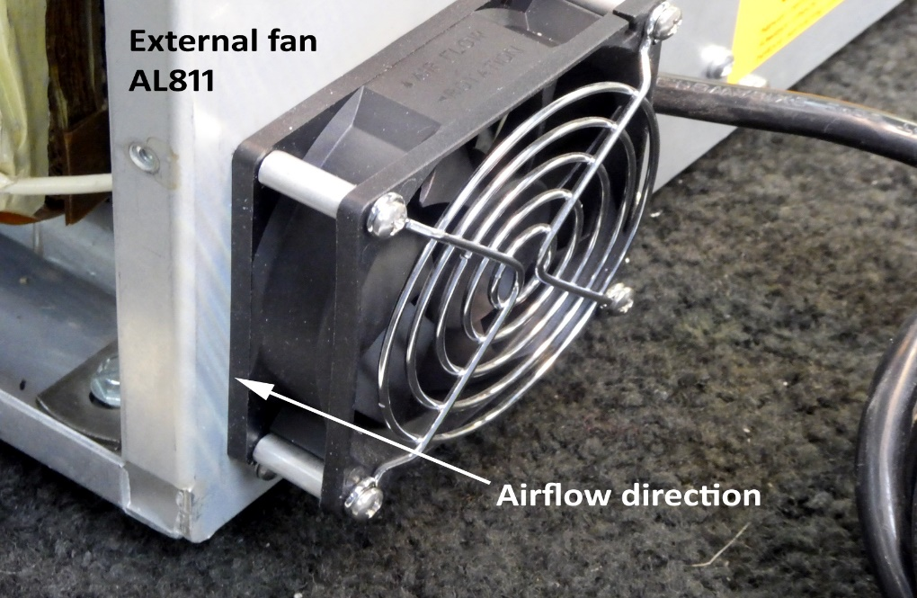
- Mount the fan in the panel, the airflow direction arrow and label points inward.

- The switch can mount with dot up to make high speed up if you like.
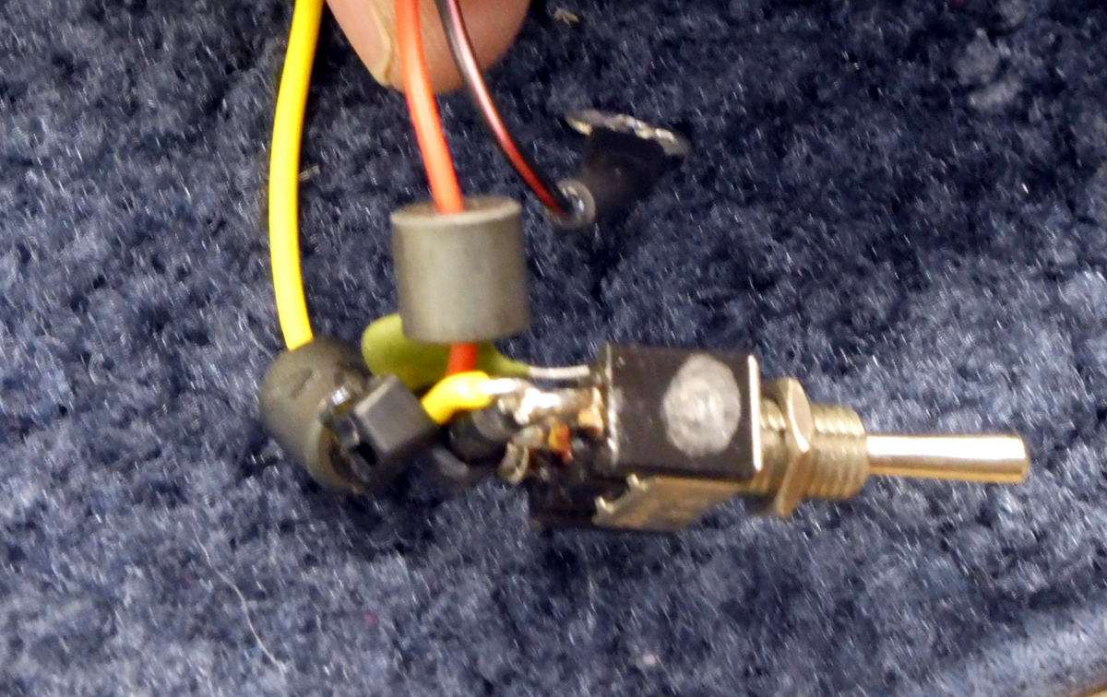
- You can either just slip the nylon cable tie for the power cord over the screw, nut it, or just through it away. It does not do much with this fan. The ground lug must be securely grounded to one of the screws. It should be sandwiched between two nuts on the outer edge top screw after the screw is tight.
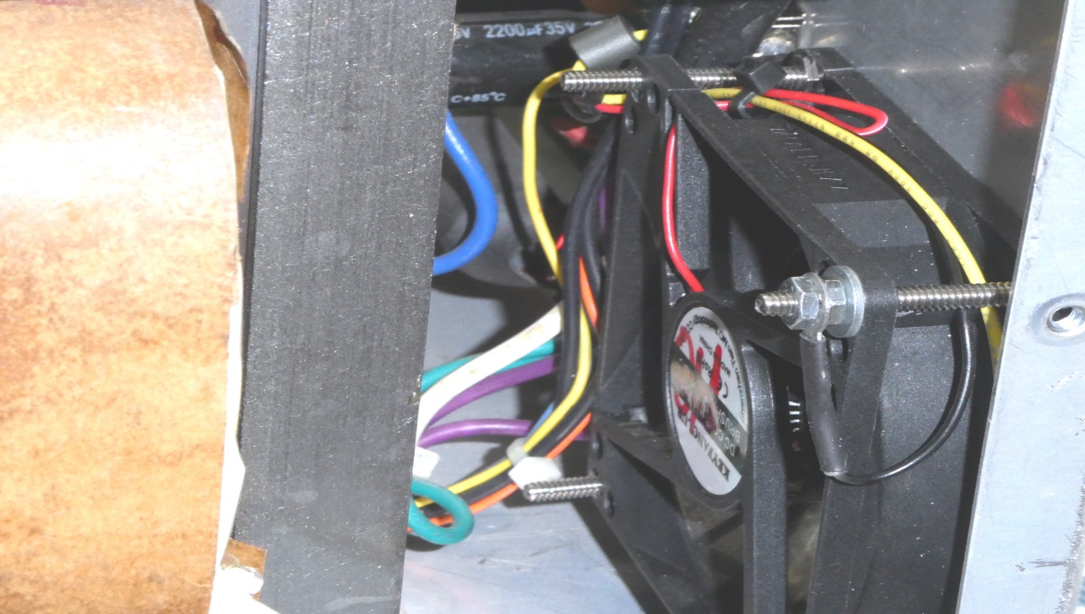

- Route the yellow fan power wire upwards along the chassis front-to-rear brace for connection to the meter yellow wire 12V lamp supply. If you wish to connect to the standby switch yellow wire point, which is more difficult, route the yellow wire along the chassis bottom to the standby switch. 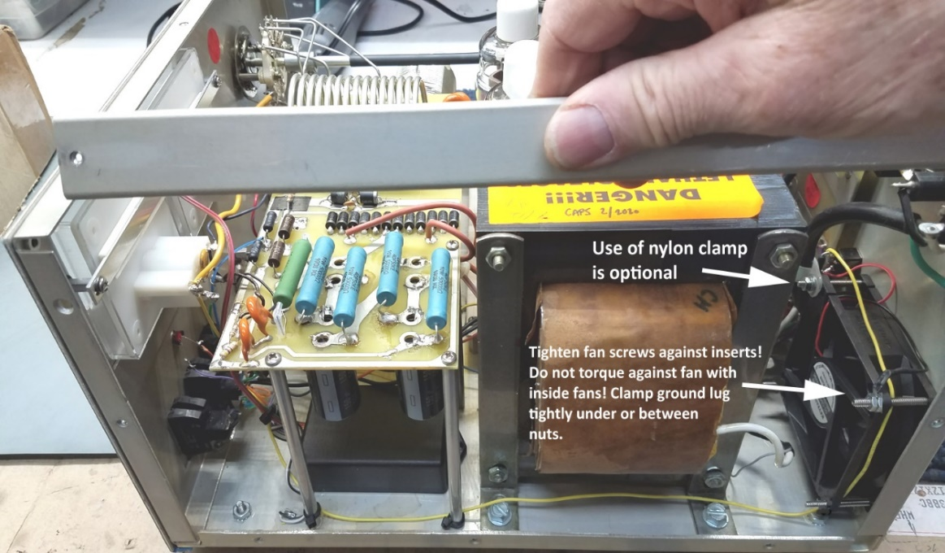
https://www.youtube.com/watch?v=YG9eHe1Bpzo

