1500 Amplifiers, GOP, or QSK Boards
All accessory boards will fit back in their original locations.
The 1500 timer/overload or GOP boards have a ground connection to make chassis contact via a board mounting pad associated with metal spacer. The shortest and quickest way to ensure a ground is to connect the black wire to a solder lug positioned like this. All other connections are normal.
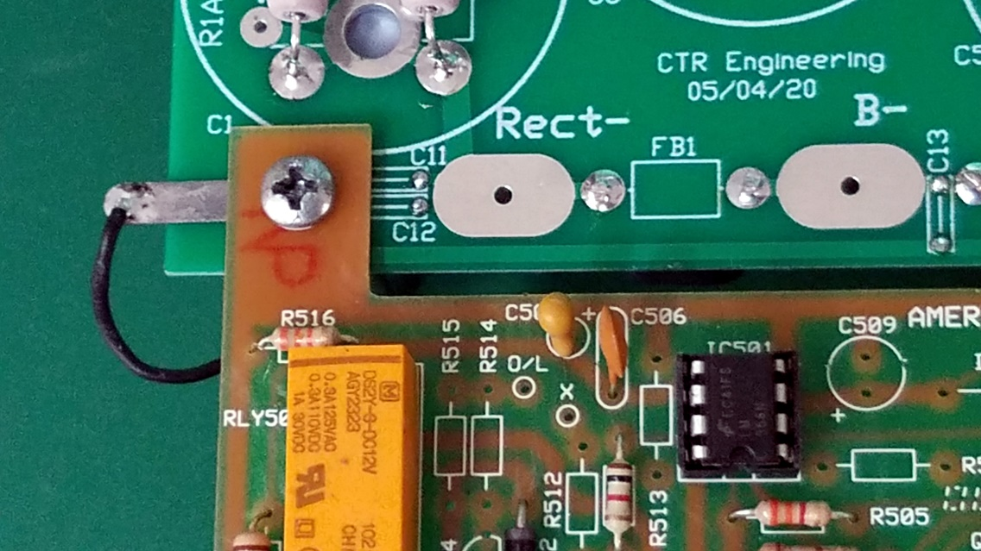
QSK Tap Point
The Ameritron QSK board requires a few hundred volts at very low current for bias. This voltage is not critical as long as it does not exceed 450 Vdc. The suitable tap point is at the top + terminal of C1 or the bottom – terminal of C2.
