Heathkit SB-200, Collins 30L-1, and Yaesu Bias System Improvements
Bias systems in the Collins 30L1, Heathkit SB200, and Yaesu FL2100 series of amplifiers are voltage divider systems.
Voltage divider bias systems work well if the load current change is small compared to standing current in the divider, but the larger the load current percentage change. Higher power class AB2 amplifiers have widely varying grid and anode currents. In the case of these amplifiers grid current can reach nearly 200mA on peaks. Since current varies so much, the voltage divider bias circuits should be converted to a stable voltage regulated bias system. This is an example of bias change in the Heathkit SB200:
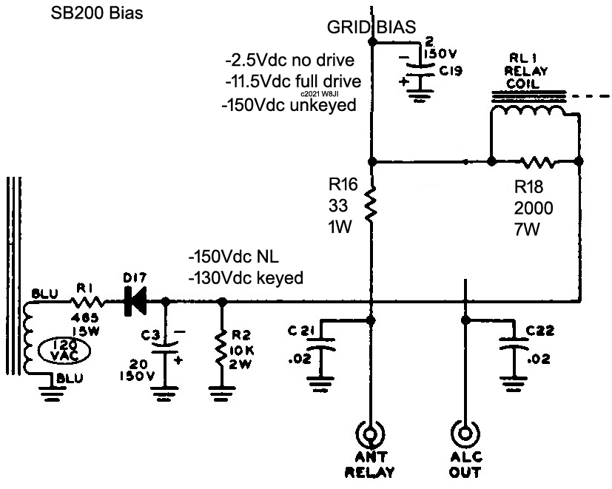
Operating grid bias in the Heathkit SB-200 is developed across R16 plus any Ant Relay path voltage drop. Measured currents in my SB-201 Heathkit were 76mA with a dead short on the ANT RELAY jack. This translates to -2.5Vdc bias at idle and about 127 volts across the 12,400-ohm relay coil and parallel 2000-ohm resistor R18. The standing current of 76mA is far too low for stable bias, since the 572B control grids can reach 150 mA or more on peaks. This can add an additional nine volts of bias, pushing the tubes into non-linear on voice peaks.
None of these amplifiers have what could be remotely considered a good bias system. They all appear to be copies of the problematic Collins bias system. These are actual measurements of a 30L-1 we rebuilt:
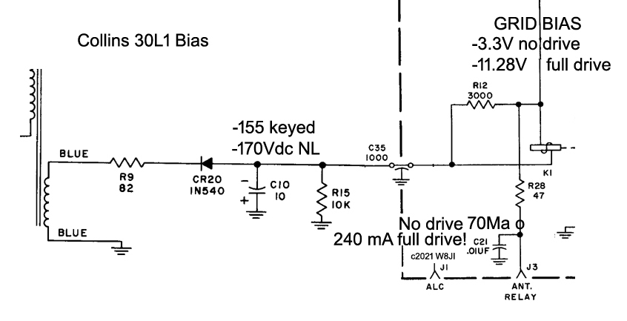
At 170mA grid current, total divider current through R28 was 240mA. Not only did the 811’s not have enough bias at idle, they had far too much bias at full drive.
The Collins and the Heathkit are easily corrected. The shunt resistor across the relay coil is removed in both amplifiers. R28 in the Collins and R16 in the Heathkit are removed and replaced with a low voltage 5-watt Zener, the diode cathode (banded end) toward the antenna jacks or soft-key circuits. I found a pair of 3.3-3.9 volt Zener diodes connected in series ideal in both the Collins and Heathkit. Target quiescent current (idle current) for minimum dissipation and intermodulation performance has typically been about 50 to 75 mA in either amplifier.
